Test Plan

|  |  |  |  |  |
| --- | --- | --- | --- | --- |
| Date | Test discretion | Entered data | Outcome | Passed |

|  |  |  |  |  |
| --- | --- | --- | --- | --- |
| 13/1/19 | Exsample test | Start program | Program started | Yes |

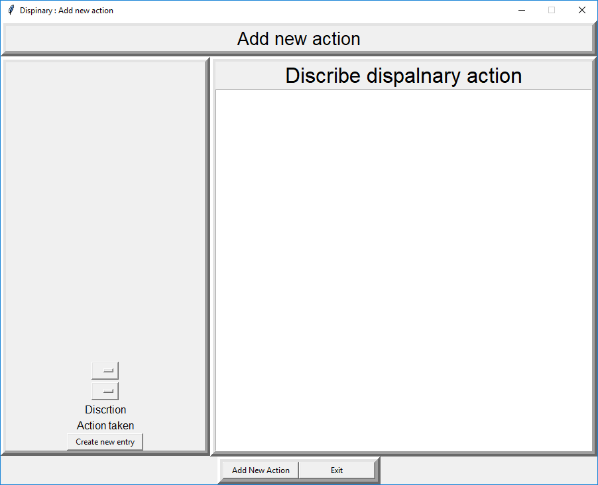

|  |  |  |  |  |
| --- | --- | --- | --- | --- |
| 13/1/19 | Example of failed test | Force program to crash | Program crsashed | No |

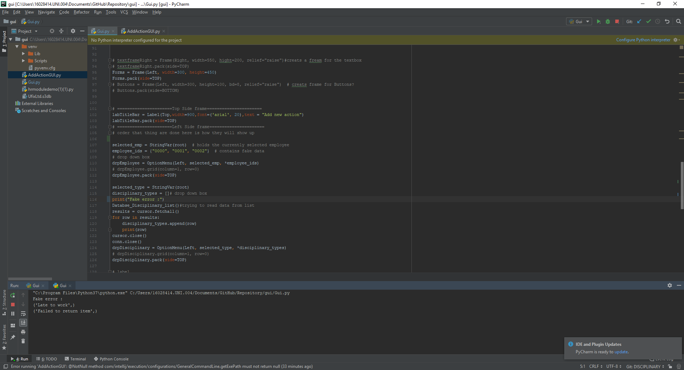

Changes: Fake error is printed, need to change to print something elts.

|  |  |  |  |  |
| --- | --- | --- | --- | --- |
| 6/3/19 | User can log in | Uername:1002  Password:root | Program logged in | yes |

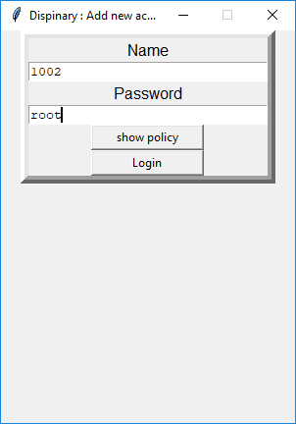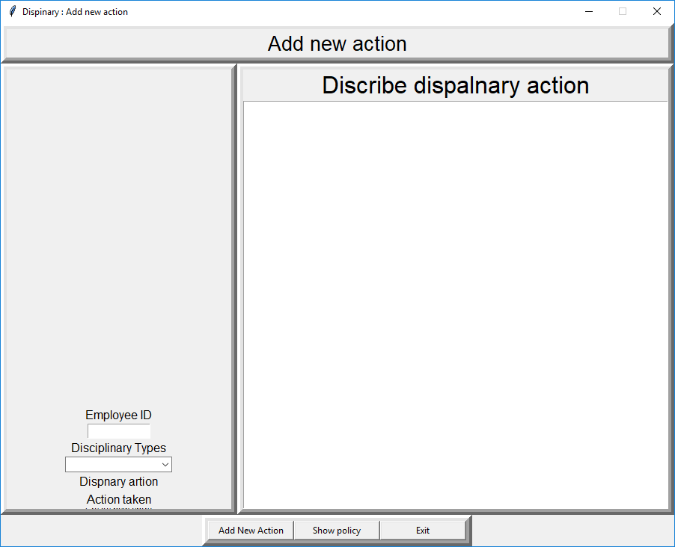

|  |  |  |  |  |
| --- | --- | --- | --- | --- |
| 6/3/19 | Increct login delats will not log user in | Username: wrong  Password: qwertyuiop | User was unable to log in | yes |

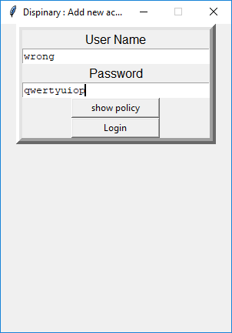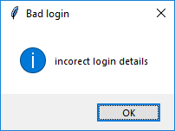

|  |  |  |  |  |
| --- | --- | --- | --- | --- |
| 6/3/19 | Show policy on the login screen will open the polcy page | Click “show policy” on the log in screen | Pressing “show policy” opend the pocliy screen | yes |

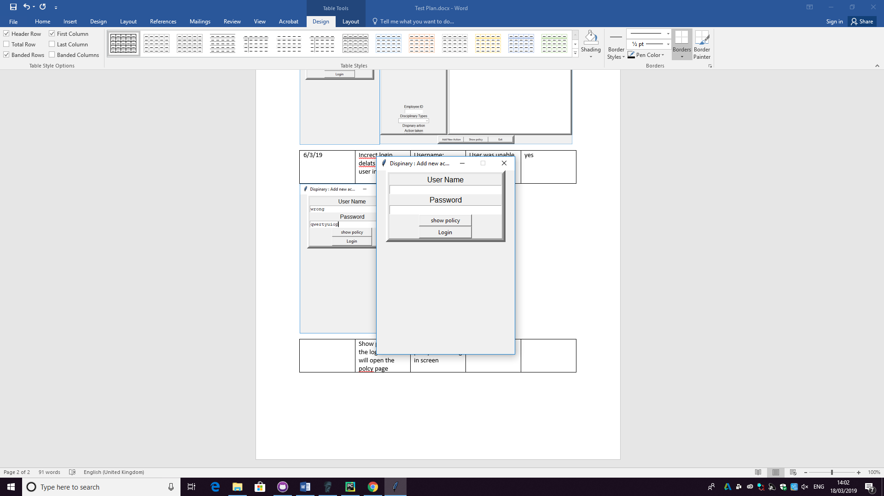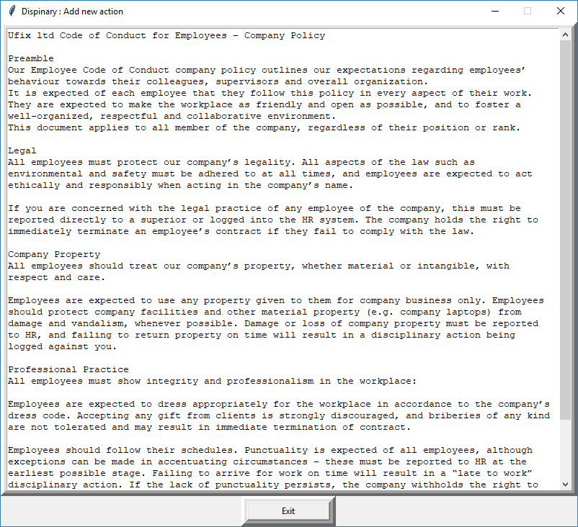

|  |  |  |  |  |
| --- | --- | --- | --- | --- |
| 21/2/19 | Main form show all disanly types in combo box | Loads data from databse | All current dispaney tyes showed up | yes |

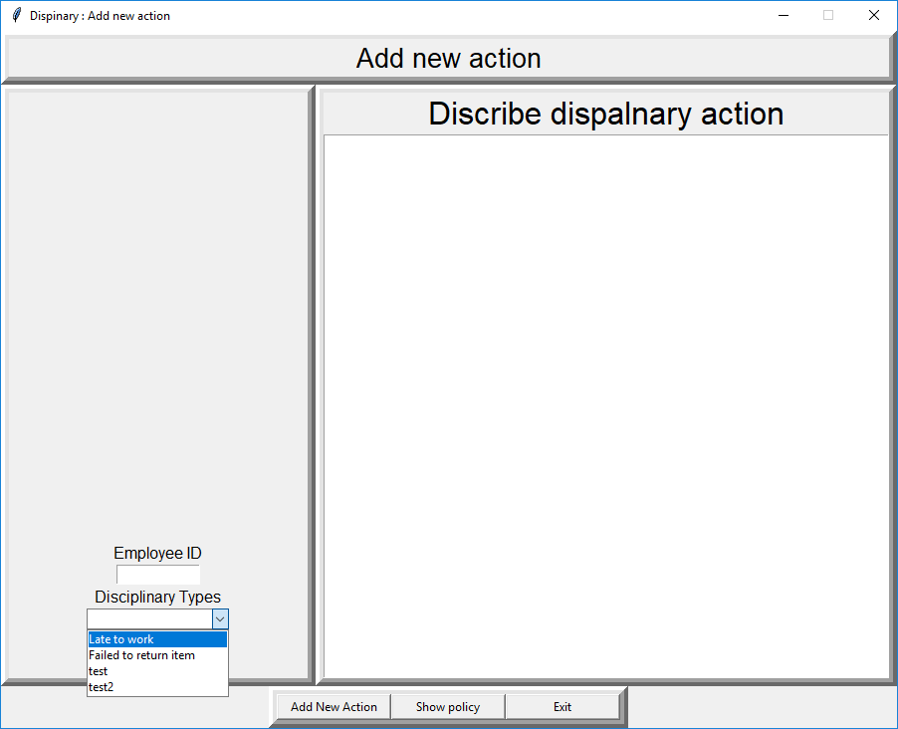

|  |  |  |  |  |
| --- | --- | --- | --- | --- |
| 27/2/19 | Chosing a disanlry type will update labes with more infomatiom | Choice late to work from combo box | Labes updates with correct infomation | yes |

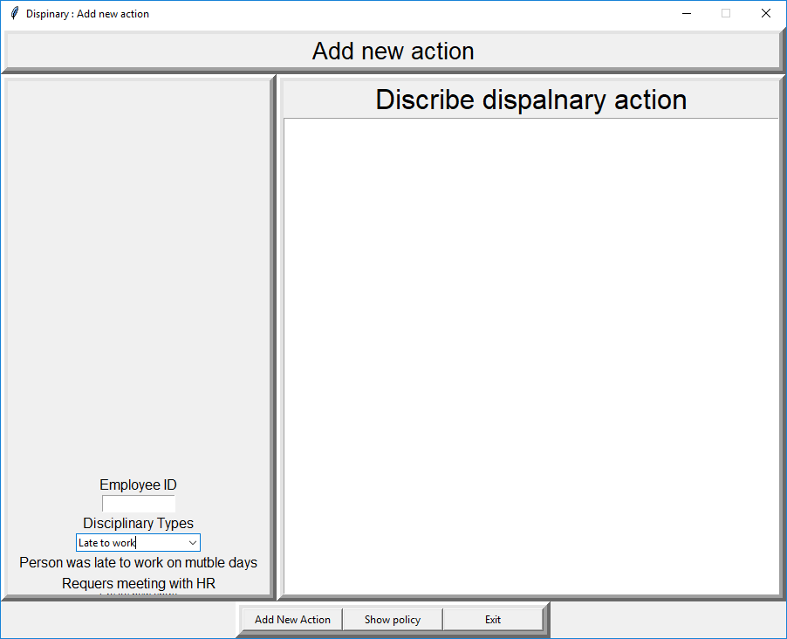

|  |  |  |  |  |
| --- | --- | --- | --- | --- |
| 27/2/19 | Clicking show policy will open the policy page | Click show policy on the main form | Poilcy form opens | yes |

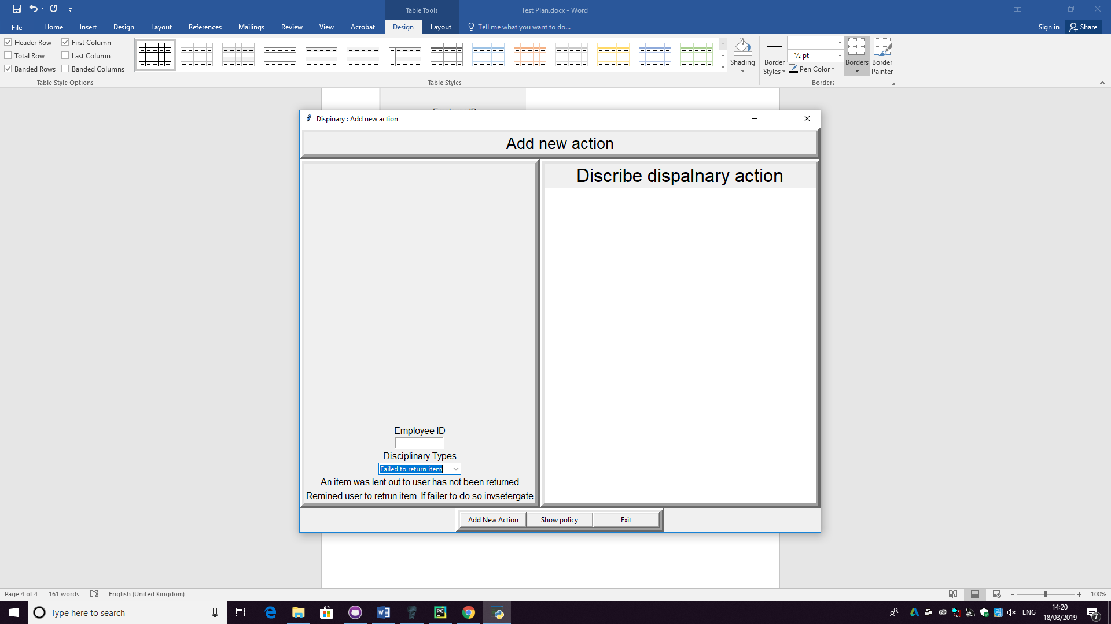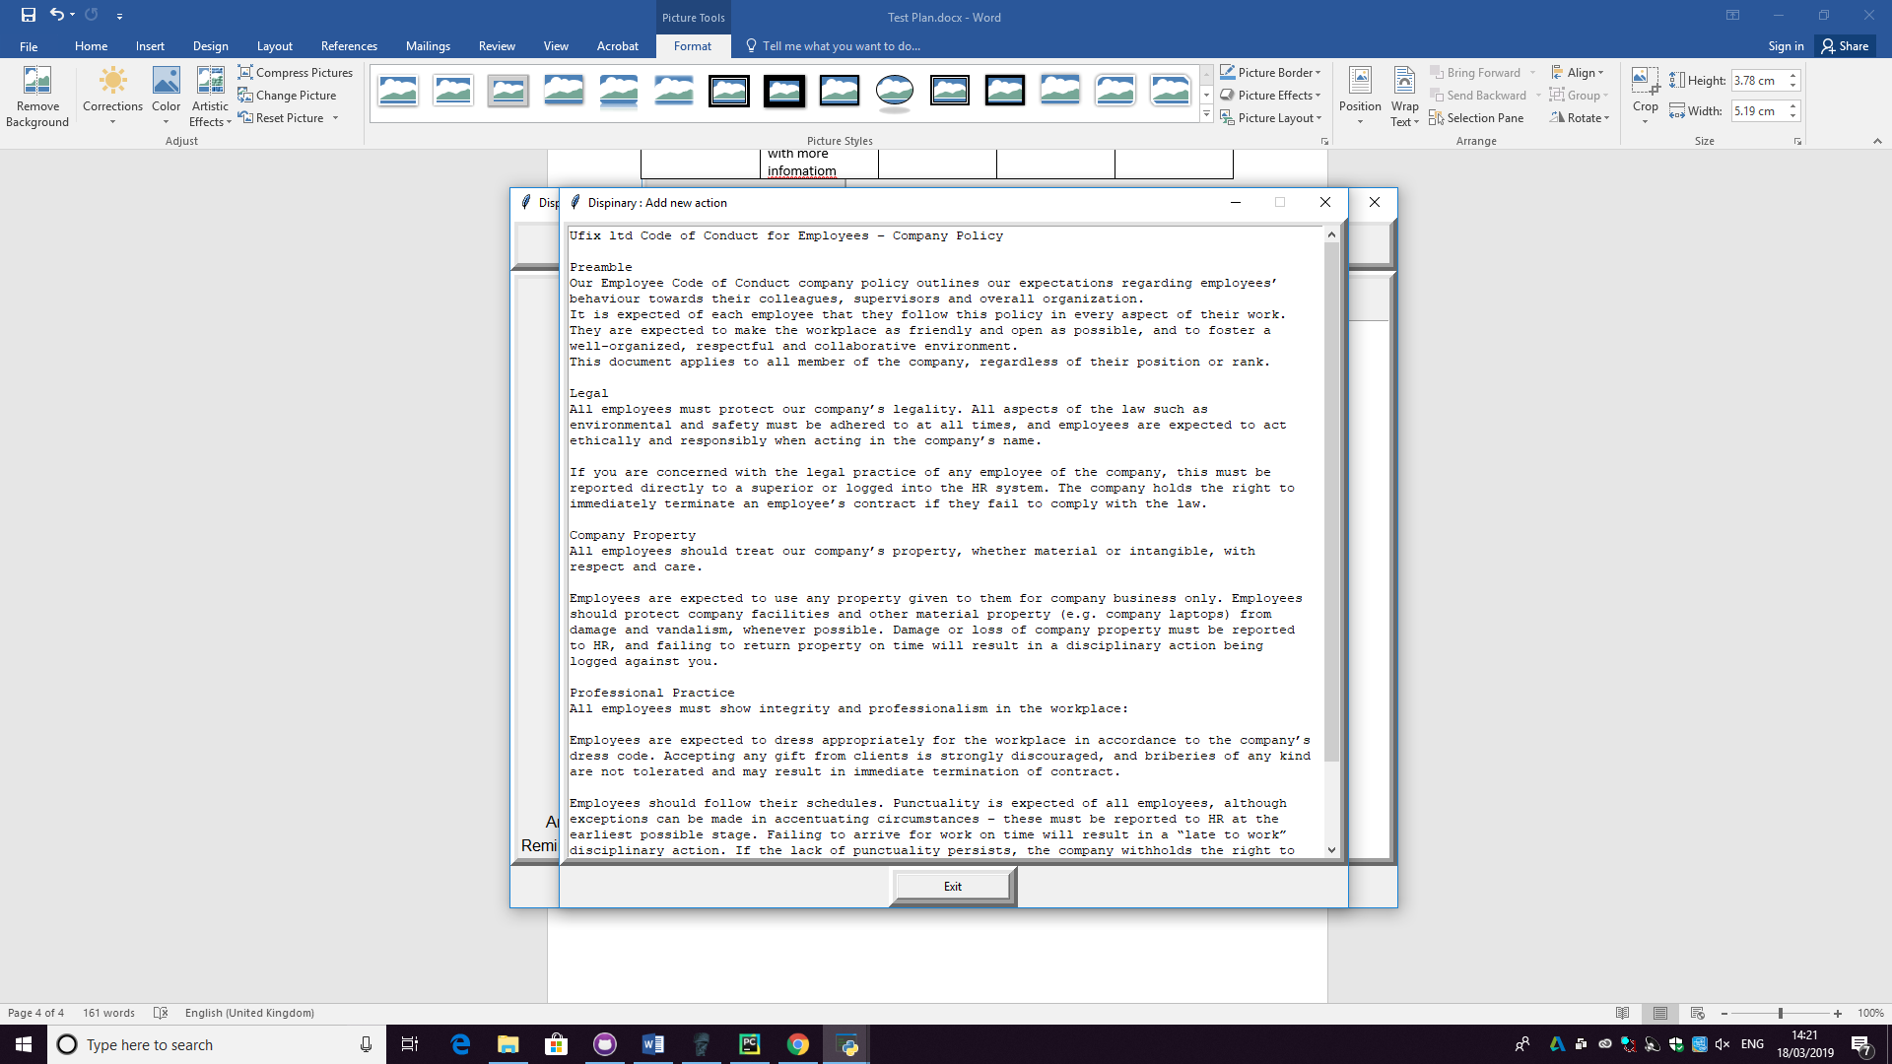

|  |  |  |  |  |
| --- | --- | --- | --- | --- |
| 1/3/19 | User can add a new dispancry action agnest someone | UserID: 1005  Displanry type: late to work  Dispanry disctions : “test discription” | The button to add a new disanry type as disaperd beine the frame used | no |

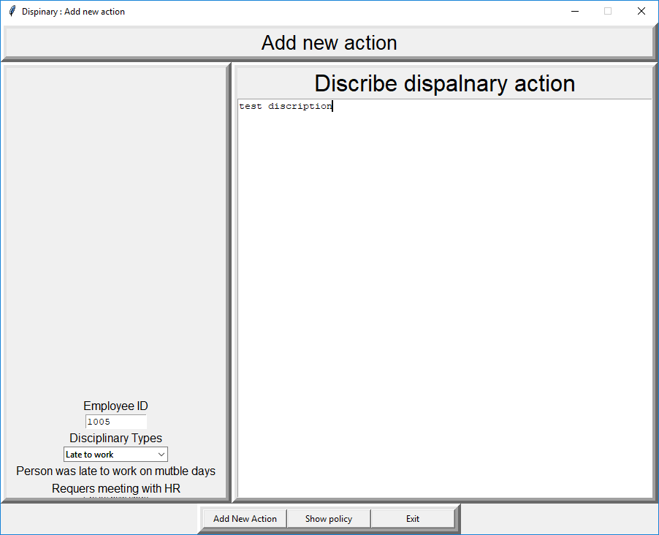 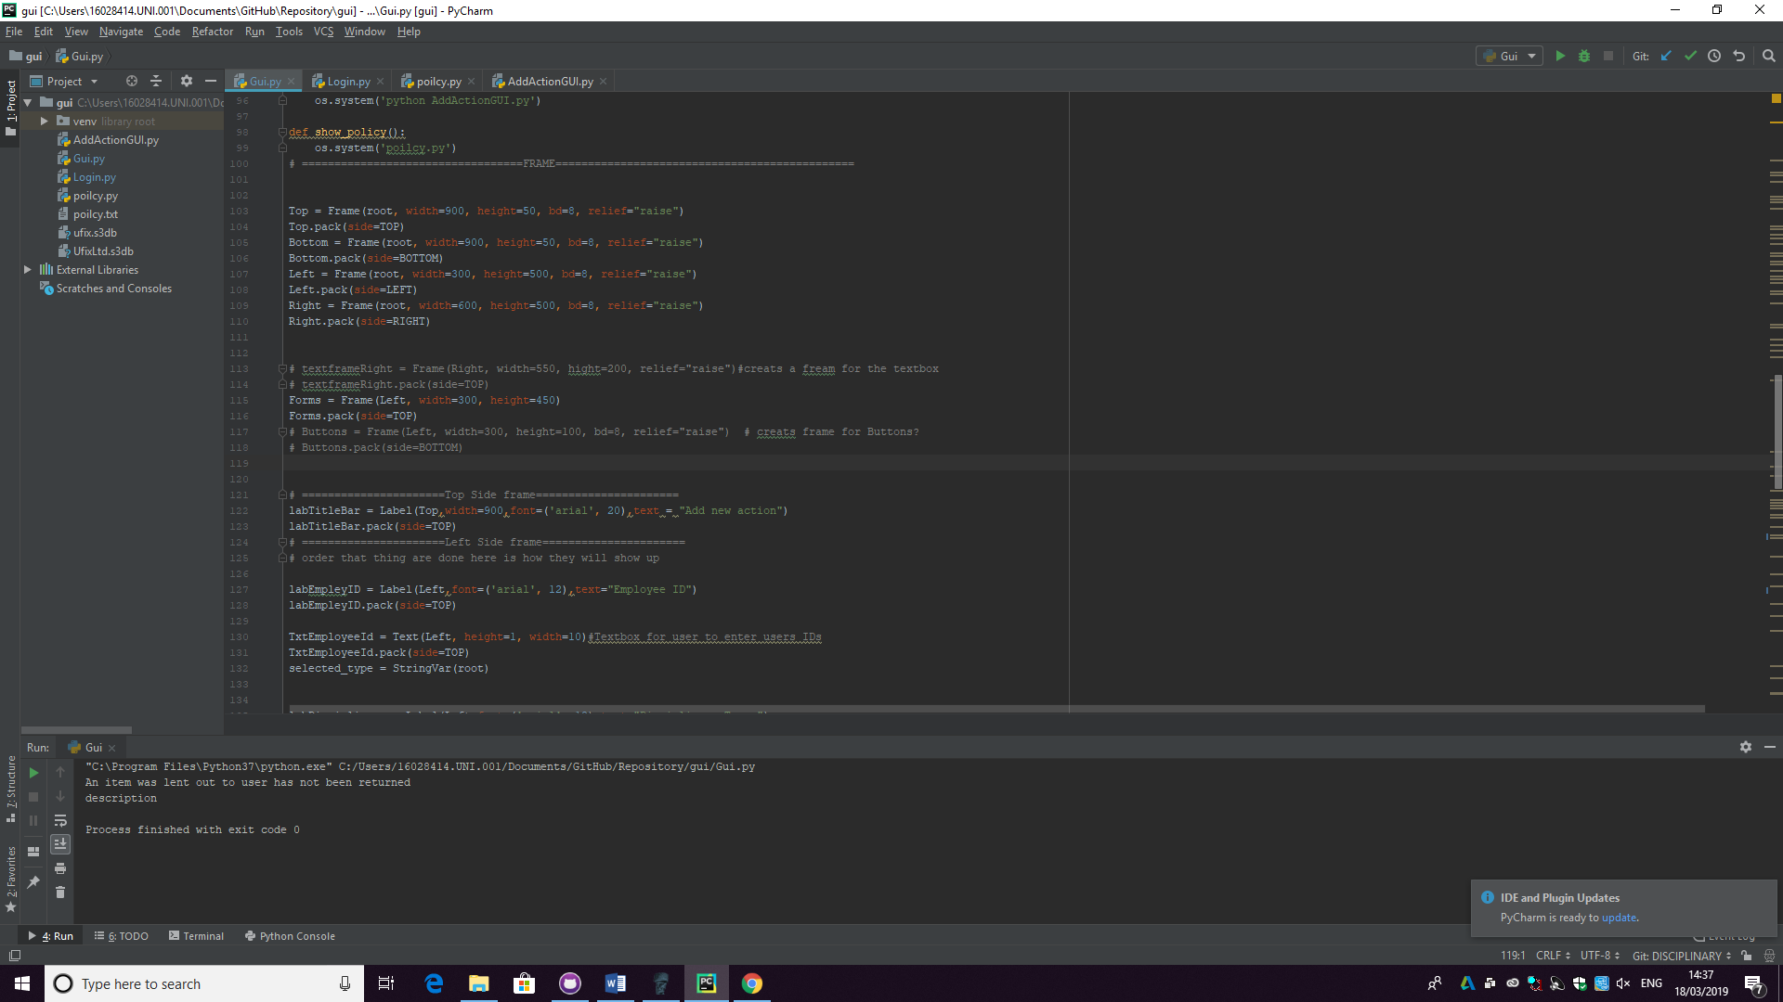a second frame was found to be in the left frame pushing everything to the bottom of the left fram. Hiding the creant new record button.

|  |  |  |  |  |
| --- | --- | --- | --- | --- |
| 1/3/19 | User can add a new dispancry action agnest someone | UserID: 1005  Displanry type: late to work  Dispanry disctions : “test discription” | Record was suffely added | yes |

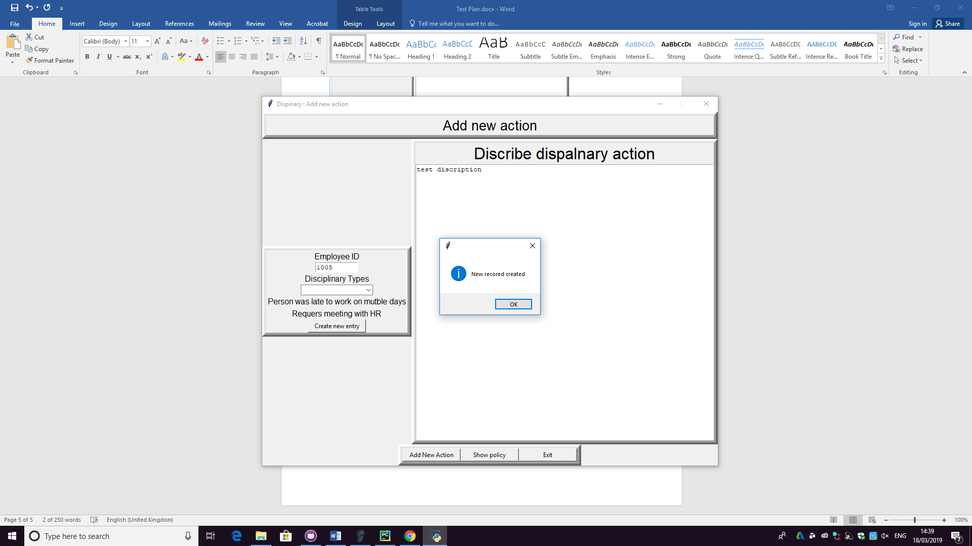

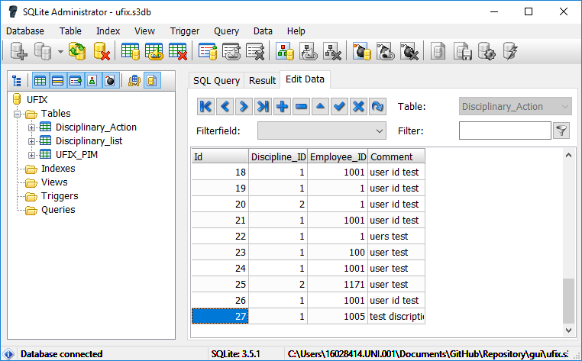data in the database

|  |  |  |  |  |
| --- | --- | --- | --- | --- |
| 1/3/19 | Main form requers a user id to creat a new record | UserID: “”  Displanry type: late to work  Dispanry disctions : “test discription” | It dose not let you add a new recored without a user id | yes |

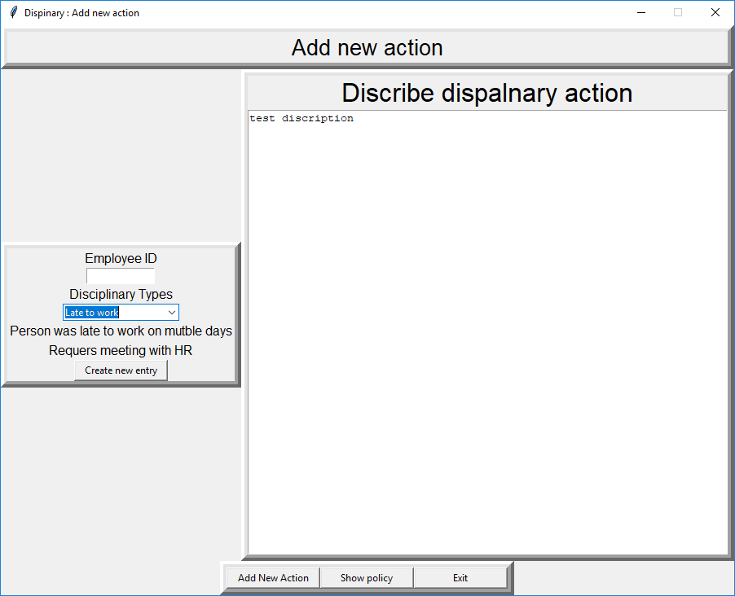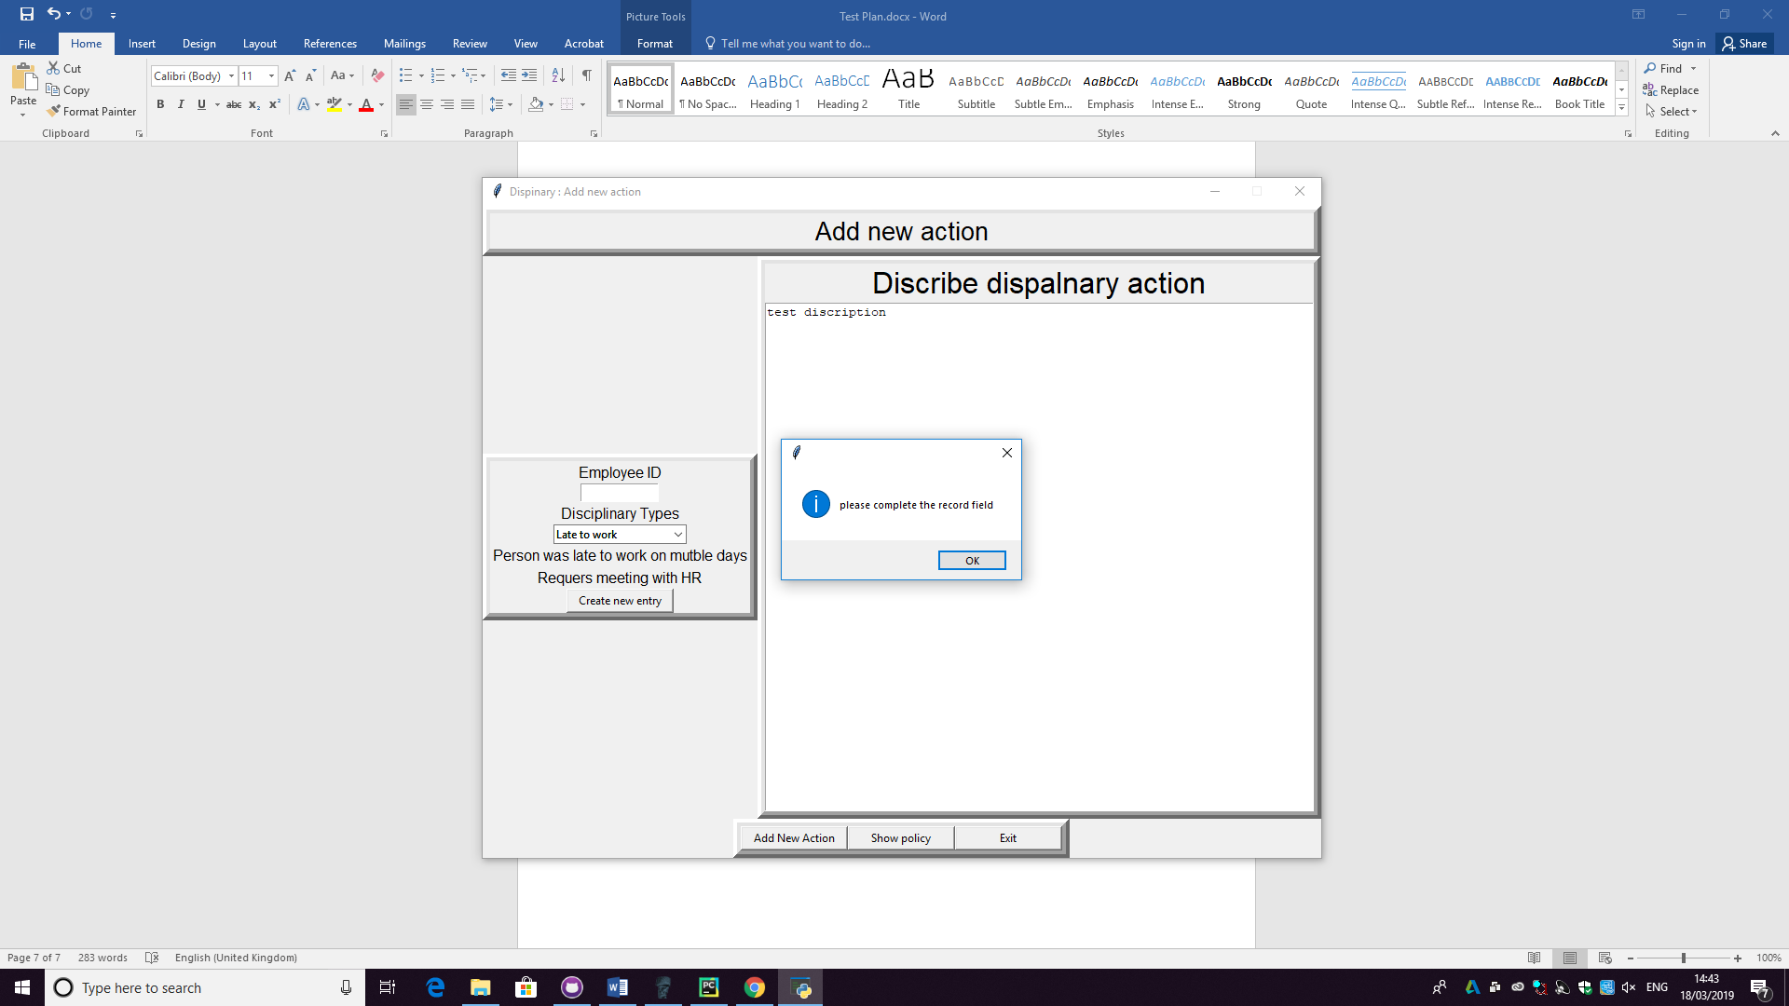

|  |  |  |  |  |
| --- | --- | --- | --- | --- |
| 1/3/19 | You must have a discretion to add a new record | UserID: “1005”  Displanry type: late to work  Dispanry disctions : “” | User cannot creat a new recored without a discrtion | yes |

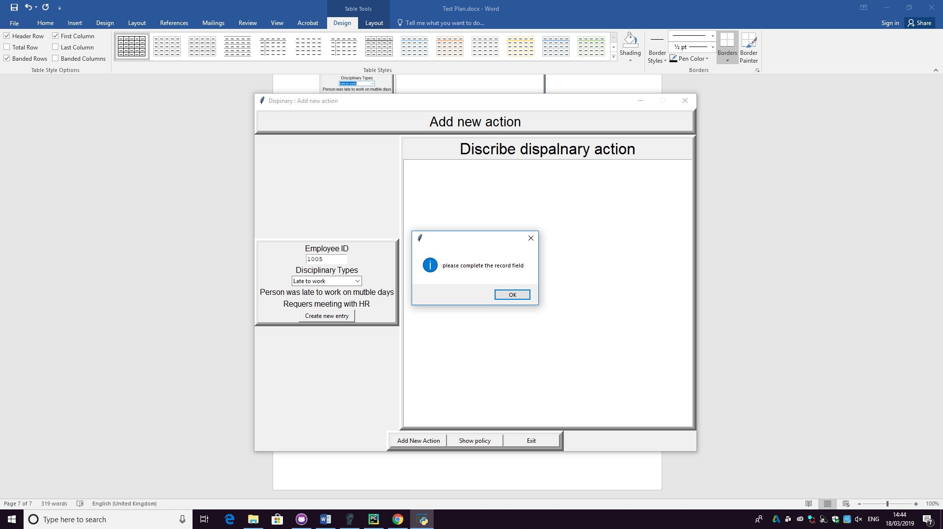

|  |  |  |  |  |
| --- | --- | --- | --- | --- |
| 1/2/19 | User must have choent a dispanry type to add a new record | UserID: 1005  Displanry type: None  Dispanry disctions : “test discription” | User cannot creat a new recored without a slected disapniary type | yes |

